Minneapolis Institute of Arts
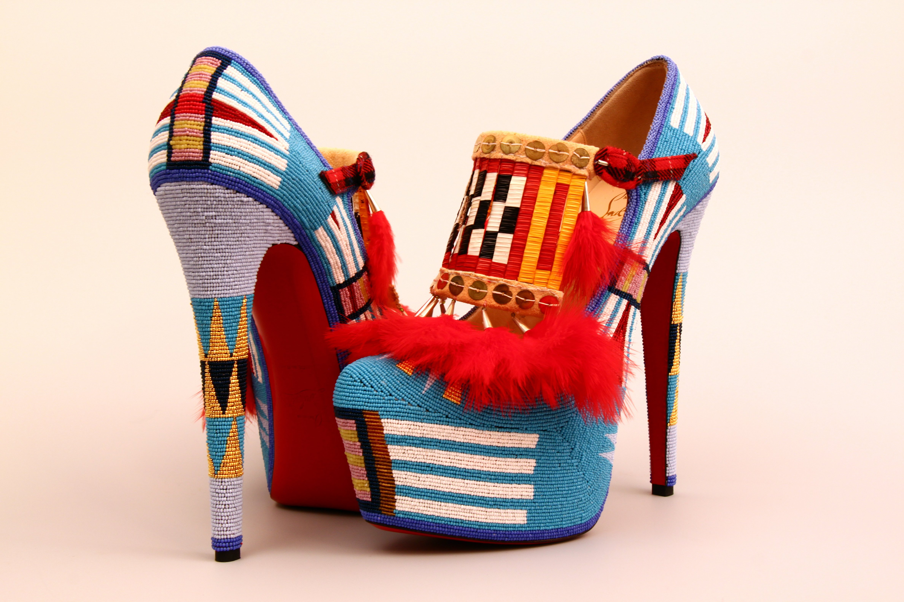
Accessions Proposal

Curator: Joe D. Horse Capture

Department: Arts of Africa and the Americas

Date: 16 November 2011

- Description and Summary of
Object or Group of Objects:

Loan Number: L2012.195a,b

Artist: Jamie Okuma, b. 1977, Luiseño/Shoshone-Bannock

Title: Adaptation II

Date: 2012

Medium: Shoes designed by Christian Louboutin, Paris (Lady Def 160), glass beads, leather, porcupine quills, tin cones, feathers.

Dimensions: shoe box size- 12"x4"x10" (30.5 x 10 x 25cms)

Signed, marked or inscribed:

Country of manufacture: USA

Vendor/Donor: From the artist

For gifts check this box if a Deed of Gift has been completed.

Credit Line: Bequest of Virginia Doneghy, by exchange

Present Location: in-route

Price/Value:

2. Artist, Style, and explanation of the proposed object:
Jamie Okuma (Luiseño/Shoshone-Bannock) is one of the celebrated Native American artists today with many awards to her credit. In the past fourteen years, Okuma has won First Place thirteen times, Best-in-Class ten times, and three Best-of-Show, at the most prestigious Native American art show, the Santa Fe Indian Market. She creates soft sculptures (dolls), outerwear, and shoes. She was educated at Palomar College and then attended the Institute of American Indian Arts for many years. Through careful research, Okuma incorporates traditional Native American designs into her work. Her coveted dolls are highly detailed and include micro glass seed beads and micro porcupine quills. She also explores fashion and has created a line of jackets that incorporate historic Native American designs with a contemporary feel. Her latest venture, decorating fashionable shoes, has attracted much attention and resulted in rave reviews of the work. Jamie Okuma is considered one of the most important contemporary Native American artists today.

3. Condition:
Excellent. A full condition report is on file in the Registrar’s office.

4. Provenance:
Created by artist.

5. Related Objects:
Beaded shoes, Nelson-Atkins Museum of Art, Kansas City, MO; porcupine quilled shoes, National Museum of the American Indian-Smithsonian Institution, Washington, DC.

6. Complements the existing collection:
There are currently over fifty pair of shoes (moccasins) in the MIA’s Native American art collection. Of that number, only one pair was made within the past 15 years (Sarah Hardisty, Dene, Arctic region, 98.13ab). The most highly decorated moccasins in our collection are fully beaded (2004.106.3ab, 99.160ab). The proposed pair of stilettos by Jamie Okuma, however, takes the collection in another direction as this native artist demonstrates the intersection of contemporary fashion with time-honored design.

7. Plans for exhibiting:
This work would be installed in the Native American art gallery (261) next to a pair of historic moccasins. These shoes would work perfectly in the gallery where contemporary Native American art has been paired with historic works, providing another example that illustrates artistic continuity throughout time.

8. Why do you recommend the object?
Many Native American artists are inspired by historic objects. They create exciting new works that give a nod to the past while also breathing new life into traditional ideas. These beaded shoes embody a creative conflation of past and present. They also speak to the vitality of native communities that fully embrace the contemporary while acknowledging and honoring their past. In the same manner that beaded and quilled moccasins in the 19th century set fashion-forward trends, this pair of stilettos forges a bold new path. Okuma’s contemporary take on historic footwear is also breathtakingly beautiful and consummately designed, making them a worthy addition to the MIA’s collection of Native American art.

9. Comparable market prices:

10. Label text:
Award winning artist Jamie Okuma has applied a Native American aesthetic to a pair of Christian Louboutin stilettos. . Meticulously beaded and quilled, they are a contemporary version of highly decorated moccasins. Okuma researches historic artwork but updates the aesthetic to appeal to contemporary native tastes and concerns.

